Develop a Web Application using frontend stack
Project layout –
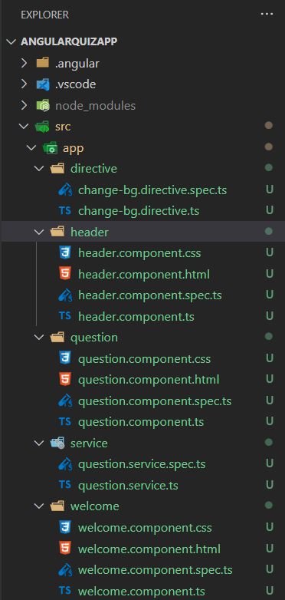
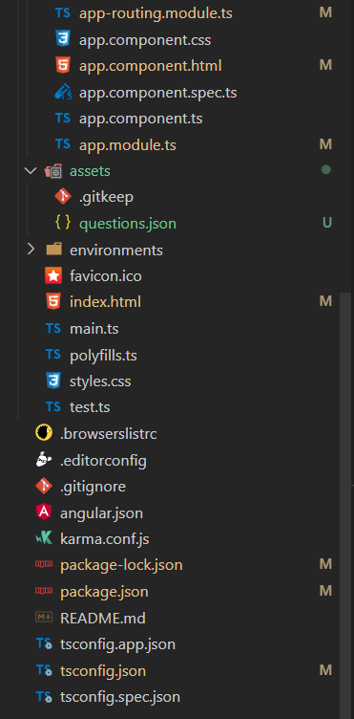

Source Code –
App.component.html:
<app-header></app-header>
<router-outlet></router-outlet>

App.routing.module.ts:
import { NgModule } from '@angular/core';
import { RouterModule, Routes } from '@angular/router';
import { QuestionComponent } from './question/question.component';
import { WelcomeComponent } from './welcome/welcome.component';

const routes: Routes = [
{ path: "", redirectTo: "welcome", pathMatch: "full" },
{ path: "welcome", component: WelcomeComponent },
{ path: "question", component: QuestionComponent }
];

@NgModule({
imports: [RouterModule.forRoot(routes)],
exports: [RouterModule]
})
export class AppRoutingModule { }

app.module.ts:
import { NgModule } from '@angular/core';
import { BrowserModule } from '@angular/platform-browser';

import { AppRoutingModule } from './app-routing.module';
import { AppComponent } from './app.component';
import { WelcomeComponent } from './welcome/welcome.component';
import { QuestionComponent } from './question/question.component';
import { HeaderComponent } from './header/header.component';
import { HttpClientModule } from '@angular/common/http';
import { ChangeBgDirective } from './directive/change-bg.directive';
import { ReactiveFormsModule } from '@angular/forms';

@NgModule({
declarations: [
AppComponent,
WelcomeComponent,
QuestionComponent,
HeaderComponent,
ChangeBgDirective
],
imports: [
BrowserModule,
AppRoutingModule,
HttpClientModule,
ReactiveFormsModule
],
providers: [],
bootstrap: [AppComponent]
})
export class AppModule { }

app.component.ts:
import { Component } from '@angular/core';

@Component({
selector: 'app-root',
templateUrl: './app.component.html',
styleUrls: ['./app.component.css']
})
export class AppComponent {
title = 'AngularQuizApp';
}

Index.html:
<!doctype html>
<html lang="en">

<head>
<meta charset="utf-8">
<title>AngularQuizApp</title>
<base href="/">
<meta name="viewport" content="width=device-width, initial-scale=1">
<link rel="icon" type="image/x-icon" href="favicon.ico">
<!-- CSS only -->
<link href="https://cdn.jsdelivr.net/npm/bootstrap@5.2.0/dist/css/bootstrap.min.css" rel="stylesheet"
integrity="sha384-gH2yIJqKdNHPEq0n4Mqa/HGKIhSkIHeL5AyhkYV8i59U5AR6csBvApHHNl/vI1Bx" crossorigin="anonymous">
<!-- Bootstrap Font Icon CSS -->
<link rel="stylesheet" href=
"https://cdn.jsdelivr.net/npm/bootstrap-icons@1.5.0/font/bootstrap-icons.css" />
</head>

<body>
<app-root></app-root>
<!-- JavaScript Bundle with Popper -->
<script src="https://cdn.jsdelivr.net/npm/bootstrap@5.2.0/dist/js/bootstrap.bundle.min.js"
integrity="sha384-A3rJD856KowSb7dwlZdYEkO39Gagi7vIsF0jrRAoQmDKKtQBHUuLZ9AsSv4jD4Xa"
crossorigin="anonymous"></script>
</body>

</html>

welcome.component.ts:
import { Component, OnInit, ViewChild, ElementRef } from '@angular/core';
import { FormControl, FormGroup, Validators } from '@angular/forms';

@Component({
selector: 'app-welcome',
templateUrl: './welcome.component.html',
styleUrls: ['./welcome.component.css']
})
export class WelcomeComponent implements OnInit {

@ViewChild('name') nameKey!: ElementRef;
exform: FormGroup;
constructor() { }

ngOnInit(): void {
this.exform = new FormGroup({
'name': new FormControl(null, Validators.required)
})
}

startQuiz() {
localStorage.setItem("name", this.nameKey.nativeElement.value);
}

}

welcome.component.html:
<div class="container bg-light py-5">
<h1 class="fw-bold">Welcome to the Quiz App</h1>
<p class="col-md-8 fs-4">This quiz will contain total 10 questions. Each question holds 10 points</p>
<h4>Rules:</h4>
<ol>
<li>Correct question gives you 10 points</li>
<li>Incorrect question gives you -10 points</li>
<li>You will have 60 seconds to answer each question</li>
<li>Refreshing the page will reset the quiz</li>
</ol>
<form name="myform" [formGroup]="exform">
<div class="name col-md-4 my-3">
<label>Enter your name:</label>
<input #name type="text" formControlName="name" class="form-control" required>
</div>
<button [disabled]="exform.invalid" class="btn btn-outline-primary" routerLink="/question" (click)="startQuiz()">Start the
Quiz</button>
</form>
</div>

question.service.ts:
import { Injectable } from '@angular/core';
import {HttpClient} from '@angular/common/http'

@Injectable({
providedIn: 'root'
})
export class QuestionService {

constructor(private http: HttpClient) { }

getQuestionJson(){
return this.http.get<any>("assets/questions.json");
}
}

header.component.ts:
import { Component, OnInit } from '@angular/core';

@Component({
selector: 'app-header',
templateUrl: './header.component.html',
styleUrls: ['./header.component.css']
})
export class HeaderComponent implements OnInit {

constructor() { }

ngOnInit(): void {
}

}

Header.component.html:
<nav class="navbar navbar-dark bg-primary">
<div class="container-fluid">
<a class="navbar-brand text-bold" href="#">
<img src="https://img.icons8.com/color/96/000000/angularjs.png" alt="logo" width="50">
<span class="text-uppercase">Angular Quiz App</span>
</a>
</div>
</nav>

question.component.ts:
import { Component, OnInit, QueryList } from '@angular/core';
import { interval } from 'rxjs';
import { QuestionService } from '../service/question.service';

@Component({
selector: 'app-question',
templateUrl: './question.component.html',
styleUrls: ['./question.component.css']
})
export class QuestionComponent implements OnInit {

public name: string = "";
public questionList: any = [];
public currentQuestion: number = 0;
public points: number = 0;
counter = 60;
correctAnswer: number = 0;
inCorrectAnswer: number = 0;
interval$: any;
progress: string = "0";
isQuizCompleted: boolean = false;
constructor(private questionService: QuestionService) { }

ngOnInit(): void {
this.name = localStorage.getItem("name")!;
this.getAllQuestions();
this.startCounter();
}

getAllQuestions() {
this.questionService.getQuestionJson()
.subscribe(res => {
this.questionList = res.questions;
})
}

nextQuestion() {
this.currentQuestion++;
}

previousQuestion() {
this.currentQuestion--;
}

answer(currentQno: number, option: any) {
if (currentQno === this.questionList.length) {
this.isQuizCompleted = true;
this.stopCounter();
}
if (option.correct) {
this.points += 10;
this.correctAnswer++;
setTimeout(() => {
this.currentQuestion++;
this.resetCounter();
this.getProgressPercent();
}, 1000);
}
else {
this.points -= 10;
this.inCorrectAnswer++;
setTimeout(() => {
this.currentQuestion++;
this.resetCounter();
this.getProgressPercent();
}, 1000);
}
}

startCounter() {
this.interval$ = interval(1000)
.subscribe(car => {
this.counter--;
if (this.counter === 0) {
this.currentQuestion++;
this.counter = 60;
this.points -= 10;
}
});
setTimeout(() => {
this.interval$.unsubscribe();
}, 600000);
}

stopCounter() {
this.interval$.unsubscribe();
this.counter = 0;
}

resetCounter() {
this.stopCounter();
this.counter = 60;
this.startCounter();
}

resetQuiz() {
this.resetCounter();
this.getAllQuestions();
this.points = 0;
this.currentQuestion = 0;
this.progress = "0";
}

getProgressPercent() {
this.progress = ((this.currentQuestion / this.questionList.length) * 100).toString();
return this.progress;
}

}

question.component.html:
<div class="card text-center">
<div class="card-header">
<div class="d-flex justify-content-between p-3">
<div class="image">
<img src="https://img.icons8.com/color/96/000000/angularjs.png" width="60" alt="logo">
</div>
<div class="quiz-header">
<h4>Quiz!</h4>
<span class="fst-italic">Welcome {{name}}</span>
</div>
</div>
<div class="d-flex justify-content-between p-3" *ngIf="!isQuizCompleted">
<div class="score">
<h5>{{points}} Points</h5>
</div>
<div class="qustion-remain">
<span class="fst-italic">Question {{currentQuestion + 1}} of {{questionList.length}}</span>
</div>
<div class="timer">
<h5>{{counter}} sec <i class="bi bi-stopwatch"></i></h5>
</div>
</div>
<div class="progress mb-3" *ngIf="!isQuizCompleted">
<div class="progress-bar progress-bar-striped bg-success" role="progressbar"
aria-label="Success striped example" [ngStyle]="{'width':progress+'%'}" aria-valuenow="25"
aria-valuemin="0" aria-valuemax="100"></div>
</div>
</div>
<ng-container *ngIf="!isQuizCompleted">
<div class="card-body">
<div class="card">
<h5>{{questionList[currentQuestion]?.questionText}}</h5>
</div>
<div class="options">
<ol *ngFor="let option of questionList[currentQuestion]?.options">
<li (click)="answer(currentQuestion+1,option)">
<div appChangeBg [isCorrect]="option.correct" class="card">
{{option.text}}
</div>
</li>
</ol>
</div>
</div>
<div class="justify-content-between">
<button [disabled]="currentQuestion==0" class="btn fs-3" (click)="previousQuestion()"><i
class="bi bi-chevron-left text-primary"></i></button>
<button class="btn fs-3" (click)="resetQuiz()"><i class="bi bi-arrow-clockwise text-primary"></i></button>
<button [disabled]="currentQuestion==questionList.length-1" class="btn fs-3" (click)="nextQuestion()"><i
class="bi bi-chevron-right text-primary"></i></button>
</div>
</ng-container>

<ng-container *ngIf="isQuizCompleted">
<div class="row d-flex justify-content-between">
<div class="result text-center">
<h3>Score Card</h3>
<p>Total Questions Attempted: {{questionList.length}}</p>
<p>Total Correct Answers: {{correctAnswer}}</p>
<p>Total Wrong Answers: {{inCorrectAnswer}}</p>
<p>Total Score: {{points}} Points</p>
<button class="btn btn-outline-primary" routerLink="/welcome">Retake Quiz</button>
</div>
</div>
</ng-container>
</div>

question.component.css:
.card {
max-width: 800px;
margin: 0 auto;
padding: 10px;
}

li {
list-style: none;
cursor: pointer;
margin: 10px 0;
}

li .card:hover {
border: 1px solid black;
}

ol {
padding: 0;
}

change-bg.directive.ts:
import { Directive, ElementRef, HostListener, Input, Renderer2 } from '@angular/core';

@Directive({
selector: '[appChangeBg]'
})
export class ChangeBgDirective {

@Input() isCorrect: boolean = false;
constructor(private el: ElementRef, private render: Renderer2) { }

@HostListener('click') answer() {
if (this.isCorrect) {
this.render.setStyle(this.el.nativeElement, 'background', 'green');
this.render.setStyle(this.el.nativeElement, 'color', '#fff');
this.render.setStyle(this.el.nativeElement, 'border', '2px solid grey');
}
else {
this.render.setStyle(this.el.nativeElement, 'background', 'red');
this.render.setStyle(this.el.nativeElement, 'color', '#fff');
this.render.setStyle(this.el.nativeElement, 'border', '2px solid grey');
}

}
}

